**DECLARATION**

I Chandana S.C, final year student of Electronics and Communication, **Karavali Instittute of Technology Neerumarga, Mangaluru-575029**, declare that the Internship has been successfully completed, in **HINDUSTAN AERONAUTICS LIMITED**. This report is submitted in partial fulfillement of the requirments for award of **Bachelor Engineering in Electroics and Communication**, during the academic year 2022-2023 under the guidance of **Ms.Sweety.T.J**

Date: Name: CHANDANA S.C

Place: USN:4KM19EC005

**ACKNOWLEDGEMENT**

The Internship is a result of accumulated guidance, direction and support of several important persons. We take this opportunity to express our gratitude to who all have helped us to complete the internship.

We express our sincere thanks to our principal Dr. Raghu Chand R sir, for providing us adequate facilities to undertake this Internship.

We would like to thank our Head of Department Ms. Rithika, for providing us an opportunity to carry our Internship and for her valuable guidance and support.

We express our deep and profound gratitude to our guide, Dr.A.N Prasanth, Head of the Fuselage Department ARDC Division, for his keep intrest and encouragement at every step in completing the Internship.

We would like to thank all the faculty members of our department for the support extended during the course of Internship.

We would like to thank the non-teaching members of our dept, for helping us during the Internship.

Last but not the least, we would like to thank our parents and friends without whose constant help, the completion of Internship would have not been possible.

**NAME: CHANDANA S.C**

**USN:4KM19EC005**

**EXECUTIVE SUMMARY**

This Internship training, carried out at Hindustan Aeronautics Limited (HAL), Bangalore, included familiarizing with the various processes involved in the company from the point of receiving of customer orders, the production processes involved, till the final dispatch of the end product to the customers. HAL have various division therefore my training is completed at the Aircraft research design centre division during the training we with systematic way. I am very happy to know that how do the done things in practically way. We are understand that various type of work and procedure how to done. It is very useful for us.

In ARDC division has a full spectrum of expertise in all facts of aircraft design and development acquired through sustained leaning and research and design. Our proven capabilities are backed by rich-in-service experience spanning over seven decades. ARDC has extensive state of the art test facilities and full fledged manufacturing infrastructure for building aircraft prototype and test articles, simulation and analysis tools to support flight development programmes.

**TABLE OF CONTENTS**

**DESCRIPTION PAGE NO.**

CERTIFICATE i

DECLARATION ii

ACKNOWLEDGEMENT iii

EXECUTIVE SUMMARY iv

TABLE OF CONTENTS v-vi

LIST OF FIGURES vii

**CHAPTER-1**

COMPANY PROFILE 1

**CHAPTER-2**

ABOUT COMPANY 2

**CHAPTER-3**

INTRODUCTION 3

**CHAPTER-4**

FUSELAGE 4

4.1 DESIGN AND DEVELOPMENT 5

4.2 WINDSHIELD COCKPIT AND CANOPY 6

4.3 COCKPIT 7

**CHAPTER-5**

FLIGHT TESTING CENTRE

5.1 RIG(RANGE INSTRUMENTATION GROUP) 9-10

**CHAPTER-6**

CDR PLAYBACK FOR JAGUAR 11-12

**CHAPTER-7**

IRON BIRD 13

**CHAPTER-8**

ELECTRICAL AVIONICS 14-15

8.1 BATTERIES

8.2 THERMAL RUN AWAY

8.3 ELECTRICAL POWER DISTRIBUTION

**CHAPTER-9**

CONCLUSION 16

**CHAPTER-10**

REFERANCE 17

**LIST OF FIGURES**

**FIGURE NO. TITLE PAGE NO.**

4.1 Fuselage of aircraft 4

4.2 Central fuselage of aircraft 4

4.3 Front fuselage of aircraft 5

4.4 Fuselage design of aircraft 5

4.5 Rare fuselage of aircraft 5

4.2a Windscreen of the canopy 7

4.2b Windshield 7

4.31 Ejection Seat 8

4.32 Cockpit of aircraft 8

6.1 Jaguar aircraft 11

7.1 Iron bird 12

8.1 Nickel-Cadmium Battery 13

8.2 Thermal runway 14

8.31 Electrical Distribution 14

**CHAPTER-1**

**COMPANY PROFILE**

**1.HISTORY**

Hindustan Aeronautics Limited (HAL) was established as Hindustan Aircraft in Bangalore in 1940 by Seth Walchand Hirachand to produce military aircraft for the initiative was actively encouraged by the kingdom of Mysore, especially by the Diwan, Sir Mirza Ismail and it also had financial help from the Indian Government. Mysore was favoured because of the availability of cheap electricity. The organization and equipment for the factory at Bangalore was set up by William D. Pawley of the Intercontinental Aircraft Corporation of New York, an exporter of American aircraft to the region. Pawley managed to obtain a large number of machine-tools and equipment from the United States. The Indian Government bought a one-third stake in the company and by April 1941 as it believed to boost British military hardware supplies in Asia to counter the increasing threat posed by Imperial Japan during Second World War. The Kingdom of Mysore supplied two directories; Air Marshal John Higgins was resident director. The first aircraft built was a Harlow PC-5 On 2 April 1942, the government announced that the company had been nationalized when it had bought out the stakes of Seth Walchand Hirachand and other promotes so that it could act freely. The Mysore kingdom refused to sell its stake in the company but yielded the management control over to the Indian Government. In 1943 the Bangalore factory was handed over to the United State Army Air Forces but still using Hindustan Aircraft management. The factory expanded rapidly and became the center for major overall and repairs of American Aircraft and was known as the 84th Air Depot. The first Aircraft to be overhauled was a consolidated PBY Catalina followed by every type of aircraft operated in India and Burma. When returned to Indian control two years later the factory had become one of the largest overhaul and repair organization in the East.in the post war reorganization, the company- build railway carriages as an interim activity. After India gained independence in 1947, the management of the company was passed over to the government of India.

**CHAPTER-2**

**ABOUT COMPANY**

HAL has established a large number of joint venture companies with world’s leading Aeronautics Organizations in several Hi-tech fields. Apart from these, various Co-production and Joint Ventures with international participation are also under consideration. Some of the latest products from HAL include the well-known Advanced Light Helicopter (ALH), Light Combat Aircraft (LCA), Intermediate Jet trainer (IJT), Sukhoi-30 and the Advanced Jet Trainer (HAWK). HAL's supplies / services are mainly to Indian Defense Services, Coast Guards and Border Security Forces but transport Aircraft and Helicopters have also been supplied to Airlines as well as State Governments of India.

The Company has achieved a foothold in exports to more than 30 countries, having demonstrated its quality and price competitiveness.With a sharp focus on lean management & novel HR initiatives, HAL is steadily marching towards accomplishment of its mission “to become globally competitive aerospace in design, related areas, managing the business on commercial lines in a climate of growing professional competence” and is stated fly higher and faster in this 21st century.

**CHAPTER-3**

**INTRODUCTION**

Is a Navratna Company and also the largest Defence Public Sector Undertaking under the Department of the Defence Production. It has 19 production Division with 9 co-located Research and Development Centres across 7 locations in the country. The division of the company are located at various locations of the country because if the whole of production is undertaken at a single location, the vulnerability to attack by enemies increases, and so most of the countries scatter their production at different places. Over more than six decades in the past, HAL has spread its wings to encompass activities in the areas of Design and Development of fixed and Rotary Wings Aircrafts, Avionics & Accessories as well as Manufacture, Maintenance, Repair and overhaul of:

* Fighter, Trainer & transport aircraft
* Helicopters
* Unmanned Air Vehicles
* Aero-engines
* Avionics
* Accessories
* Ground Support equipment

HAL has established a large number of joint venture companies with world’s leading Aeronautics Organizations in several Hi-tech fields. Apart from these, various Co-production and joint Ventures with international participation are also under consideration. Some of the latest product from HAL include the well know Advanced Light Helicopter (ALH), Light Combat Aircraft (LCA), Intermediate Jet Trainer (IJT), Sukhoi-30 and the Advanced Jet Trainer (HAWK). HAL’s supplies/services are mainly to Indian Defence Services, Coast Guards and Border Security Forces but transport Aircraft and Helicopters have also been supplied to Airlines as well as State Government of India.

The Company has achieved a foothold in exports to more than 30 countries, having demonstrated its quality and price competitiveness. With a sharp focus on lean

**CHAPTER-4**

**FUSELAGE**

It is an aircraft main body section. It holds crew passengers. In single engine aircraft, it will usually contain an engine as well, although in some amphibious aircraft the single engine is mounted on a pylon attached to the fuselage, which in turn is used as a floating hull.

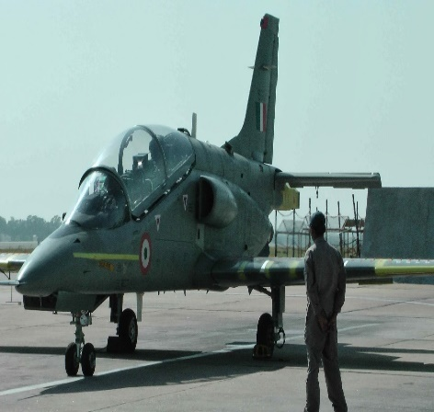

Fig 4.1:-Fuselage of aircraft

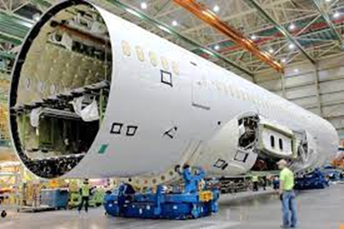Fuselage of aircraft have a total #38stationaries these stationaries divided into three parts they are front fuselage(#1 to #21), central fuselage(#21 to #30) and rare fuselage(#30 to #38).

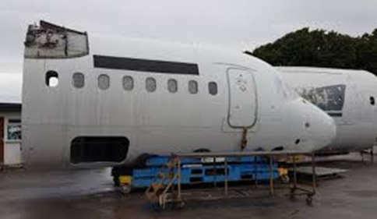 Fig 4.2:-Central fuselage of aircraft

Fig 4.3:-Front fuselage of aircraft

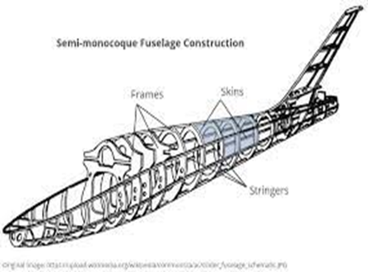

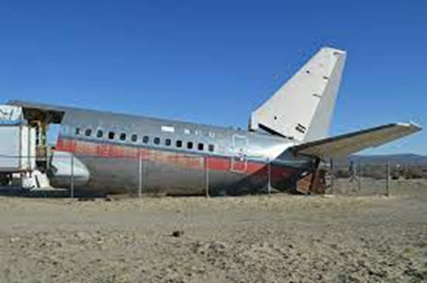 Fig 4.4:-Fuselage Design of aircraft

Fig 4.5:- Rare fuselage of aircraft

**4.1 DESIGN AND DEVELOPMENT**

The fuselage is the name given to the main body of the aircraft and houses the pilots, crew, passengers, and cargo. The wings and tail section are attached to the fuselage, and depending in the design of the aircraft, may include engine attachments too.

The fuselage does more than just house the occupants of the aircraft; it must be sized and designed to ensure that the wings and tail are positioned in such a way so as to keep the aircraft statically stable through the designed center of gravity envelope. A statically stable aircraft is one that will tend to return to straight and level flight if the controls are released, which is a requirement for all civil general aviation aircraft.

The fuselage is one of the primary contributors to the total drag force produced by an aircraft in flight and so must be carefully shaped to be as aerodynamic as possible in an effort to minimize drag. There is of course some balance that must be sought between low aerodynamic drag and payload and passenger comfort.

The fuselage structure must be sufficiently strong to ensure safe operation throughout the flight envelope. A semi-monocoque structural design is usually favoured; where the sub-structure and transfer the loads generated during flight.

Trainer aircraft

* Pilatus-Basic
* HJT-16 (Kiran MK-I, MK-II)
* HJT-36 sitara
* BAE Hawk

ARDC

* Intermediate jet trainer
* Light Combat aircraft-Tejas
* LCA MK-I
* Hindustan Turboprop trainer
* Mini UAV

**4.2 WINDSHIELD COCKPIT AND CANOPY**

Windshield is nothing but Windscreen which provides visibility while protection occupant from the element.

Windscreen is unlike windows, the flight deck windshields are made with glass-faced acrylic an outer layer of glass bonded to stretched acrylic. Then, there’s a layer between them, made of urethane. Each has anti-ice and anti-fog system. In the case of boeing 787, there are then layers of stretched acrylic, just like the cabin window, albeit much thicker between one and three inches thick depending on the aircraft.

Have you ever noticed that the cockpit windshields sometimes look like they have oil on them ? that oil sheen is actually a coating of Indium tin oxide, which is a conductive material between the layer and transmits heat. Accordingly, this thin windows nice and clear in frosty weather brillian

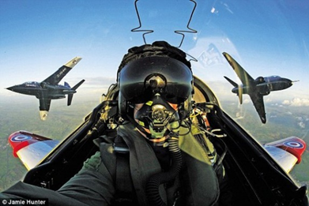

Fig 4.2a:- Windscreen of the canopy

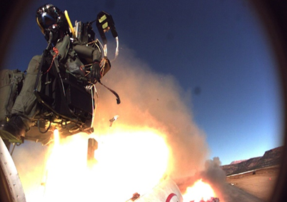

Fig4.2b:-Windshield

**4.21 COCKPIT**

Cockpit is also known as flight deck, this is an area, usually near to the front of an aircraft from which a pilot to fly the aircraft.

The cockpit of an aircraft contains flight instrument panel, and the controllers that enables the pilot to fly the aircraft. In most airlines, a door separates the cockpit from the aircraft cabin.

In aircraft, an ejection seat is a system designed to rescue the pilot from the defender attack or explosive missiles and bombs. In emergency, the seat is propelled out of the aircraft by an explosive rocket motor, carrying the pilot with it. The concept of an escape crew capsule has also been tried. Once clear of the aircraft, the ejection seat deploys a parachute (1000 feet) to landing.

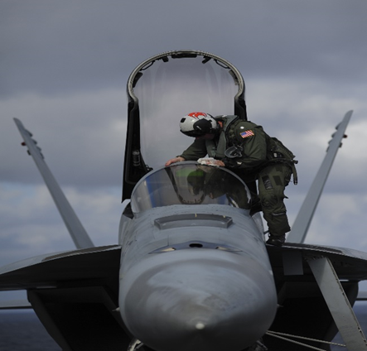

Fig 4.31:- Ejection seat

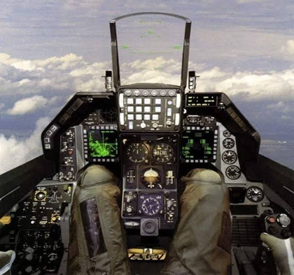

Fig 4.32:-Cockpit in aircraft

**CHAPTER-5**

**5. FLIGHT TESTING CENTRE**

5.1 RIG (Range instrumentation group)

Rig room:- In this lab where pre-installation sub-system integration, clearances of all on board line replaceable unit is carried out before installing in the prototype aircraft.

RIG room activities

1. Maintenance and upgradation of flight test instrumentation Rig for LCA and IJT projects.
2. Pre-installation checks of onboard LRUs
3. Pre-installation sub-system integration of onboard LRUs
4. PCM format generation and loading
5. Sang rectification of onboard LRUs
6. Calibration and maintenance of sensor stock
7. GPS Data acquisition
8. Design and development
9. CDR replay
10. Maintenance of mobile and V|UHF communication

Facilities at FTI RIG

1. Test panel RACK-I
2. Test panel RACK-II
3. Test panel RAK-III
4. Simulator patch panel RACK-IV
5. Test panel RACK-V (test and measurement)
6. Test panel RACK-VI (FM)
7. Test panel RACK-VII (SGDAU)
8. Test panel on RACK-IX (Video)

Space segment:- 24 satellites placed in 12hours period orbit. They travel at a velocity of 3.9km\sec, altitude of 22000km.

Control segment:- It is associated with ground facilities carrying out task of satellite tracking, supervision necessary for the dairy control of the space segment. (Master control station).

Dual redundant data bus (DRDB)

Each mode connected to each of redundant bus if one bus should fail the communication will contain in another bus

Bus Controller

Initial all message traffic on bus can command remote terminal receive or transmit data

Remote terminal

It provide interface 1553 bus and sub-system. Respond to message we sent from bus controller An each remote terminal has its our unique address 31 remote terminals in 1553B Fixed bit rate 1Mbps Half dyster Twist schielded terminated or each end Two methods for connecting anode to the bus Direct coupling- Stub length up to 1 foot Transformer coupling- Stub length up to 20 feet Receiver data- bus to remote terminal (0-30) Transfer data- bus to remote terminal Broadcast data- Can command 32 bit word data Mode code- Manage information transferring system RT to RT transfer

CHAPTER-6

**CDR PLAYBACK FOR JAGUAR**

Crash Data recorder or flight data recorder is a crashworthy device that records data about an aircrafts flight, such as airspeed, heading and the procedures of the pilot, also called black box.

The FDR in the aircraft records many different operating conditions of the flight up to 24 Analog parameters like attitude, flap, engine RPM etc.. and 11 discrete indications like under carriage weapon etc..

Crash the flight data recorder in encased in heavy steel and surrounded by multiple layer of insulation to provide against a crash, fire and extreme climatic condition. The device records pitch the FDR is installed in the rear of the aircraft

FDR technology was combined with a flight data acquisition unit, located at the relay for the entire data recording process sensors run from various areas on the plane to the FDAU, which in turn sends the information to the FDR.

In the early days, data were embossed onto a type of magnetic foil known as Incanol steel. The foil proved to be destructible and FDR manufacturers began using a more reliable from of magnetic tape. Electromagnetic technology remained the data recording medium of until the late 1990, when solid state electronics began to show promise. SSR relay on stacked arrays of non-moveable memory chips. The technology is considered more reliable than magnetic tape, as the lack of moving parts provides a reduced chance of breakage during a crash.

FDR records only the critical parameters of the aircraft in addition to the pilot’s voice, with the data retrieved from the FDR is stored in a magnetic spool, the recorded data can generate a plot of the flight path. The investigator can visualize the airplane’s attitude, instrumentation readings, power settings and other characteristics of the flight. This plot enables the investigating team to visualize the health condition of the flight or last moments of the flight before the accident.

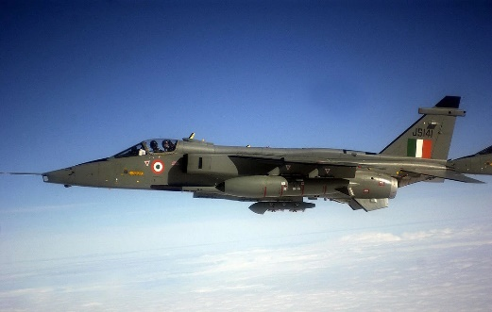

Fig 6.1:- Jaguar aircraft

**CHAPTER-7**

**IRON-BIRD**

An iron-bird is a ground based test device used for prototyping and integrating aircraft systems during the development of new aircraft design. Aircraft systems are installed into the iron-bird so their functions can be tested both individually and correlation with other systems. Iron-birds are used for system integration, reliability testing and shakedown testing of aircraft systems such as landing gear, avionics, hydraulics, and flight controls. The components may be arranged roughly in the same layout as they will be in the final aircraft design, but left accessible for ease of maintenance. Some iron-bird also include pilot inputs and simulated flight profiles, and can be used in pre-flight pilot training. Others are used for testing of propulsion systems.

Iron-birds can also be used after aircraft certification for troubleshooting ongoing issues and for testing of proposed modifications prior to fleet integration.

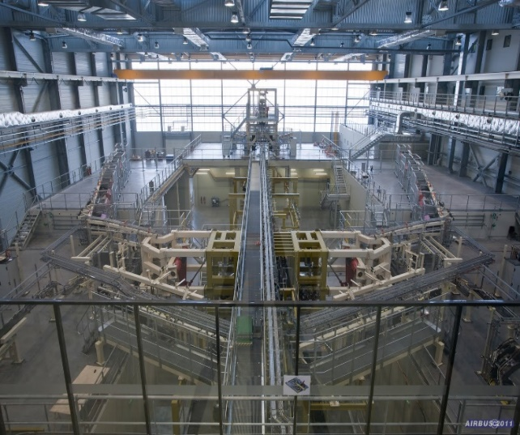

Fig 7.1 :- FIG of Iron-bird

**CHAPTER-8**

**ELECTRICAL AVIONICS**

Electrical power sources must function properly in combination or independently. Failure of any electrical power sources should not impair the ability of the remaining source of supply. Each ‘EPS’ control must allow independent operation in repeat of regulation and protection, at least one independent source for supplying circuits that are essential for such operation of aircraft.

Each EPS should be monitored and failure of source to be indicated provision should be available for powering up all the aircraft systems from external power.

* 1. Batteries

To help maintenance the DC system voltage under transient condition. Internal starting of an engine for supplying limited electrical power during emergency condition. Batteries are kept float charged under normal flying condition (20 to 30min battery span) battery is a device convert chemical energy into electrical energy.

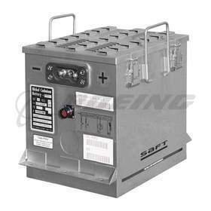

Fig 8.11:- Nickel-Cadmium battery

**8.2THERMAL RUN AWAY**

A condition which causes violent gassing, boiling of the electrolyte and finally melting of the plates and casing with consequent temperature. When the current flow battery heat up when temperature increases resistance decreases so the electrical flow increases and finally blast nickel-cadmium battery face this condition. Temperature sensing devices are located within the battery to provide the information to pilot.

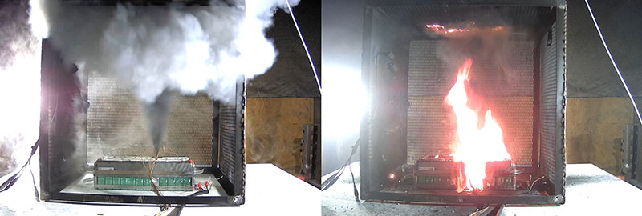

Fig 8.2:- Thermal runaway

**8.3 ELECTRICAL POWER DISTRIBUTION**

Power from the source, to be made available at the terminals of the power consuming equipment then an organized from of distribution throughout the aircraft. The pressurise manner in which this is arranged is governed principally by the type of aircraft and its electrical system, number of consumers and location of consumer point.

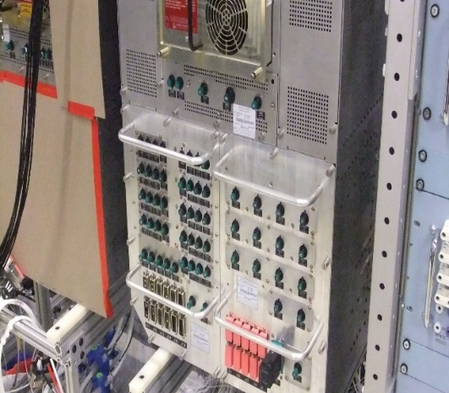

Fig 8.31:- Electrical power distribution

**CHAPTER-9**

**CONCLUSION**

My Internship Consists of an Exchange of services for Experience Between the Intern and The organization. Internships. Are Used to Determine If the Intern Still Has an Interest in That Field of Real-life Experience and Has been Performed Basis What theory Instructed.

As Main Purpose of Internship Is to learn by Working in practical Environment and to Apply the Knowledge Attained During the Studies in The Real world Scenario in order to Tackle the problem Using the knowledge and Skills Learning During the Academic Process. We learn about Testing, Designing and landing of Aircrafts.

In The end Experience Section Consists of Task Assignment, skills Acquired and Experiences During Internship Program Has been Discussed in detail. This report mainly consist my prerception about the Employee Satisfaction, Motivation level and working Environment of the Organization

**CHAPTER-10**

**REFERANCE**

1. <https://hal-india.co.in>
2. Wikipedia
3. Theoretical input in training centre
4. [www.google.com](http://www.google.com)